THE UNITED REPUBLIC OF TANZANIA
MINISTRY OF NATURAL RESOURCES AND TOURISM
PASIANSI WILDLIFE TRAINING INSTITUTE
 | “55 Years of Excellence in Providing Training in Wildlife Conservation, Tourism and Paramilitary disciplines”  P.O. Box 1432 Mwanza -Tanzania  Telefax: +255-282-560333  E-mail: principal@pasiansiwildlife.ac.tz  Website: www.pasiansiwildlife.ac.tz | 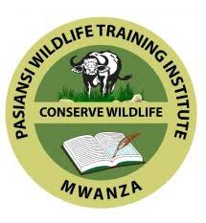
Historical Background of PWTI
Pasiansi Wildlife Training Institute (PWTI) attained its establishment Order in 2020 by the Wildlife Conservation Act. No. 5 of 2009, Cap. 283, section 96 (1), through the Government Notice No. 465. At time of its inception in 1959 by then Fauna Conservation Ordinance of 1959, Cap. 302, PWTI was known as Natural Resources Institute (NRI). The Institute was registered by National Council for Technical Education in 2002 with a full accreditation for five years from March 2017.
Training Programs
The Institute offers four programs under the National Technical Award (NTA) system recognised by the National Council for Technical Education (NACTE) and a range of customer structured short courses as shown in the table below;
Table 1: Training programs under NTA level system
S/No | Program Name | Level | Duration
1 | Basic Technician Certificate in Wildlife Management and Law Enforcement (BTCWLE) | NTA 4 | 1 year
2 | Technician Certificate in Wildlife Management and Law  Enforcement (TCWLE) | NTA 5 | 1 year
3 | Basic Technician Certificate in Tour Guiding and Tourism Safety (BTCTGS) | NTA 4 | 1 year
4 | Technician Certificate in Tour Guiding and Tourism Safety (TCTGS) | NTA 5 | 1 year

Table 2: Currently Short Courses offered at the college
S/No | Program Name | Duration
1 | Short Courses in Wildlife Management (for Village Game  Scouts in wildlife conservation, climate change, intelligence,  wetlands, etc.). | 1 month - 3 months
2 | Paramilitary Transformation short courses in Forestry surveillance and Wildlife Management | 3 months

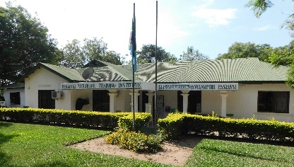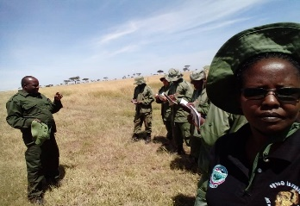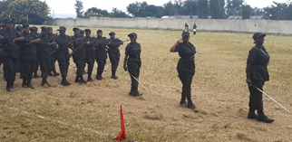
PWII photos showing main office, on field facilitation and short course student pass out parade
Vision
To be a centre of excellence in providing training in wildlife law enforcement
Mission
To produce quality wildlife rangers for protecting wildlife resources through offering paramilitary, wildlife management, law enforcement and security training, as well as research and consultancy services.
Philosophy of PWTI
The PWTI mission will be accomplished through effective partnerships and commitment to principles of good governance. The policies and actions of PWTI will be developed and implemented to build stakeholders' trust and in a manner that encourages employee's teamwork.
PWTI Motto
Passionate about wildlife resources
ADMISSION REQUIREMENTS:
TCWLE and TCTGS
The Technician Certificate in Wildlife Management and Law Enforcement and Technician Certificate in Tour Guiding and Tourism Safety targets applicants with either:
Possession of Advanced Certificate of Secondary Education Examination (ACSEE) from National Examinations Council of Tanzania (NECTA) with at least one principal and one subsidiary passes in any subjects and holder of Certificate of Secondary Examination Education (CSEE) with minimum of four passes in Biology and Geography for TCWLE and Biology and English for TCTGS at O -level. OR
Possession of Basic Technician Certificate in Wildlife Management and Law Enforcement, Wildlife Management, Tourism and Tour Guiding, Basic Certificate in Tour Guiding and Tourism Safety, Basic Technician Certificate in Wildlife Management, Basic Technician Certificate in Tourism and Hospitality from any accredited Training Institution from inside and outside Tanzania
BTCWLE and BTCTGS:
The Basic Technician Certificate in Wildlife Management and Law Enforcement and Technician Certificate in Tour Guiding and Tourism Safety targets applicants with either:
Applicants must have completed Certificate of Secondary Education Examination (CSEE) with at least four (4) passes including passes in Biology and Geography for BTCWLE and Biology and English for BTCTGS excluding religious subjects. OR National Vocational Award (NVA) level III with at least four passes at O-Level. Candidates should be certified physically fit by a recognized physician. This is because the course entails paramilitary training.
Special courses:
Applicants with work experience in the wildlife sector from WMAs District Councils and NGOs.

